AWS Networking Basics Overview:-

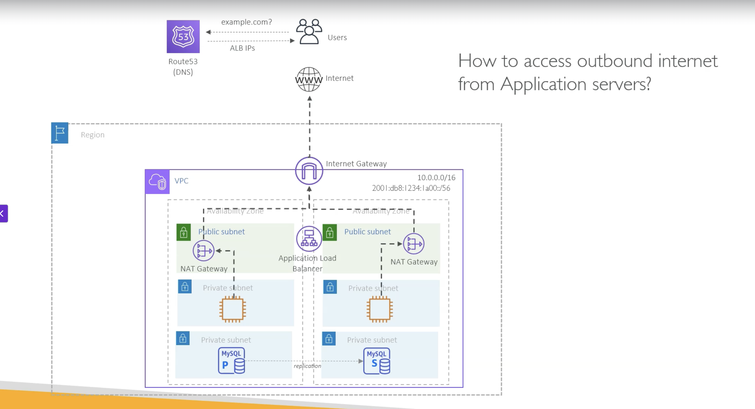

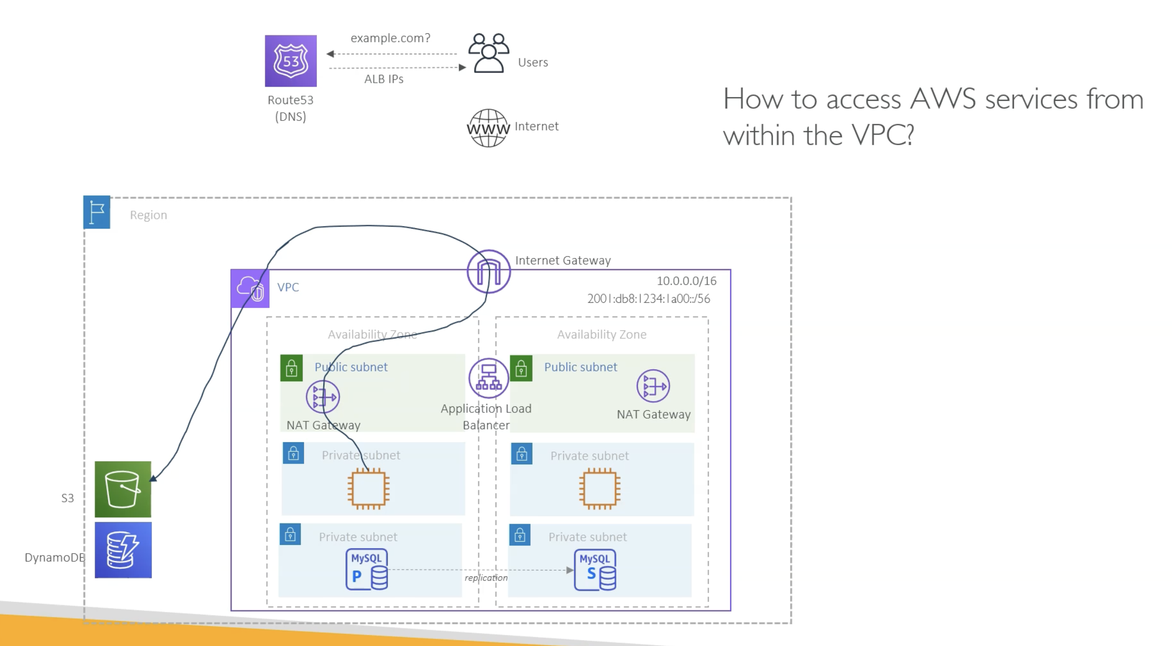

But access to S3 and other services is again through the internet.

That means if your application server has to upload or download data from S3 or DynamoDB, it would

have to take this route, right?

And if you are downloading too much data or uploading too much data, there could be also some additional

data transfer charges because the data is traveling through the Nat gateway.

There is a data processing charge for that.

So it is not cost efficient as well as it is not efficient because it is going through multiple hops,

right.

So in order to solve this problem, what AWS says, if your target AWS service is in the same AWS region

as your VPC, then instead you can use something called VPC endpoints.

And in AWS there are two types of endpoint.

One is VPC gateway endpoint which allows you to access S3 and DynamoDB.

These two services privately.

For that, you don't need to send the traffic through the Nat gateways.

So traffic will go something like this.

Similarly, there is another type of endpoint which is powered by AWS Privatelink.

And in there you can use hundreds of AWS services endpoints privately from within the VPC.

So you can create as many interface endpoints for those services, and you can privately access those

AWS services.

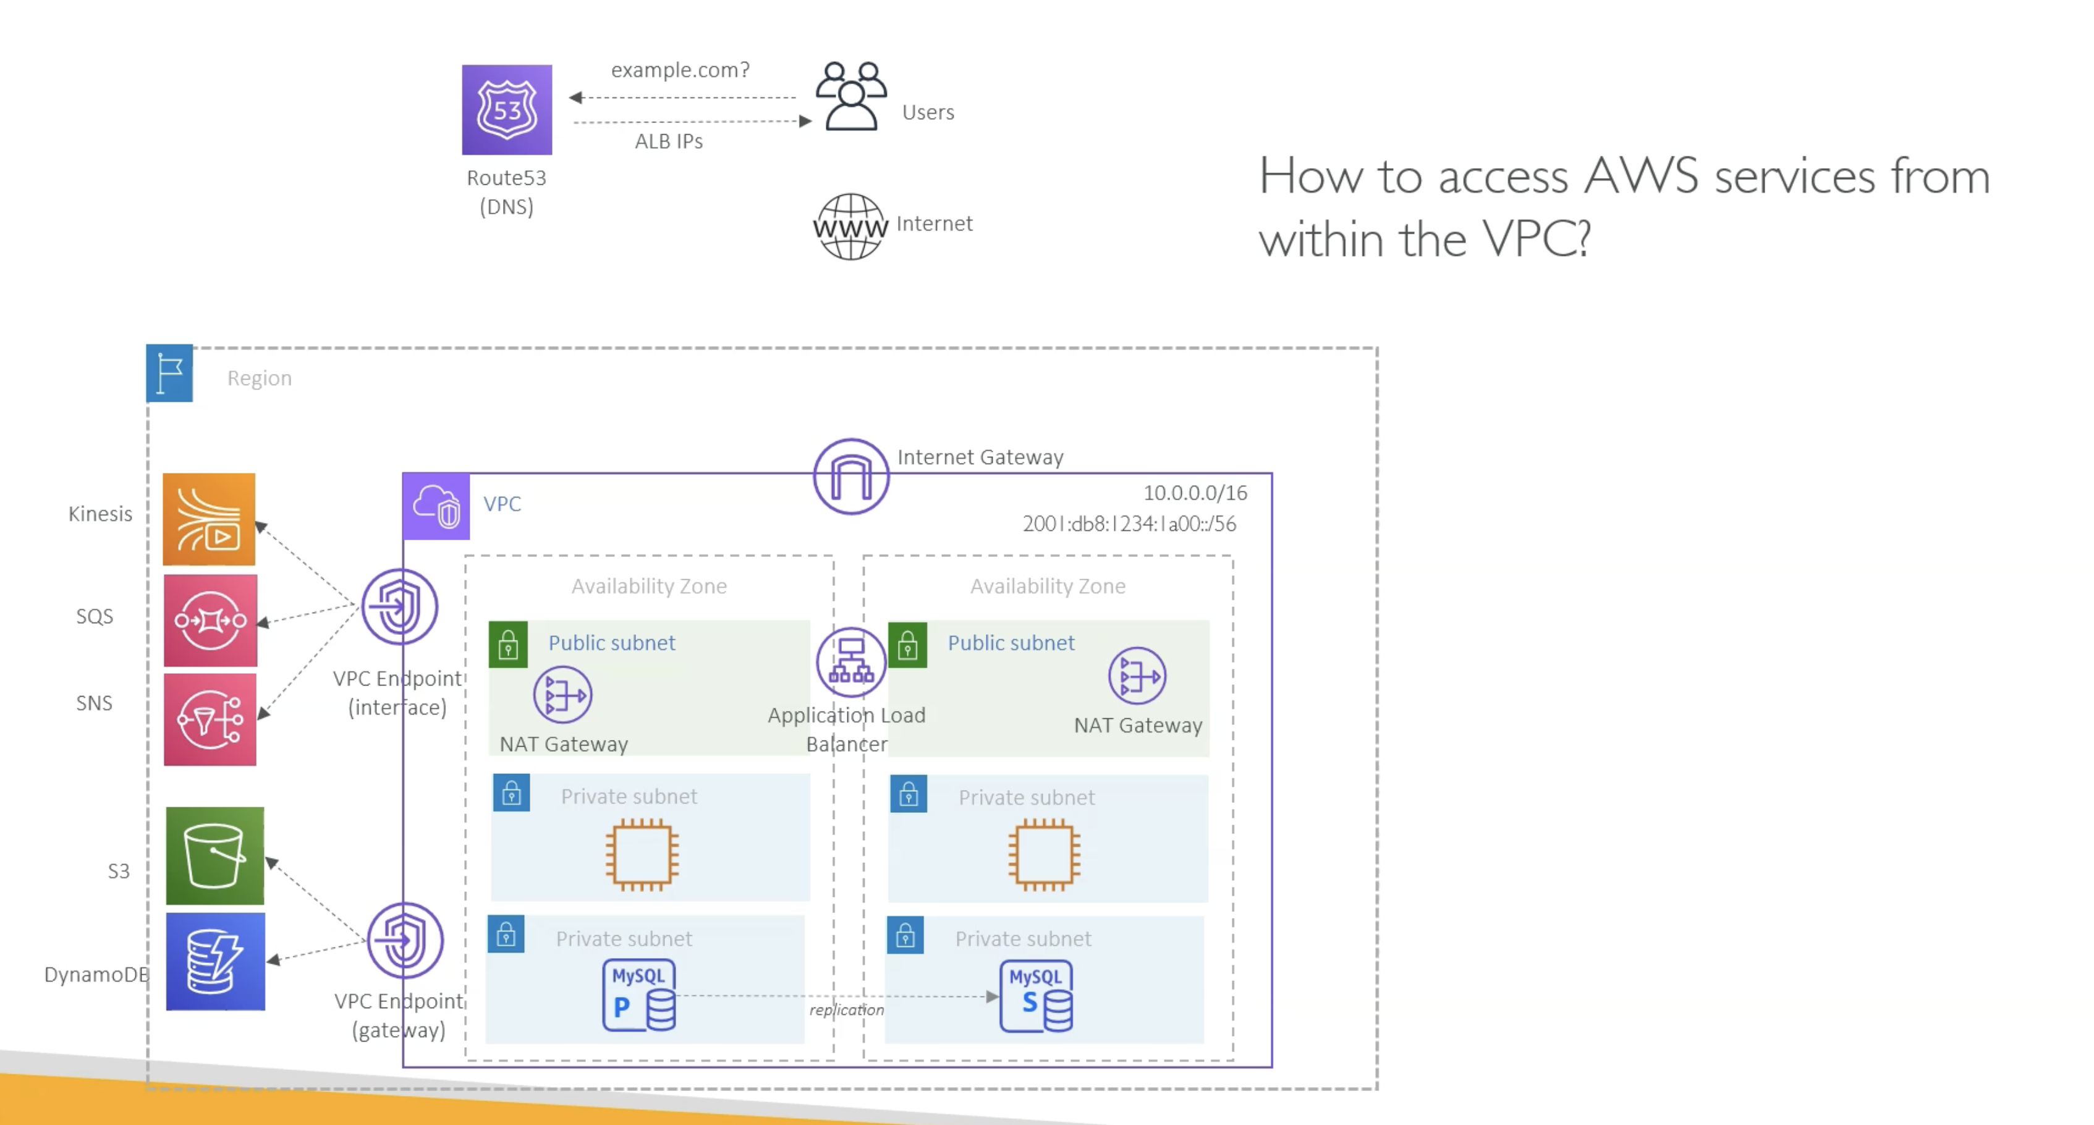

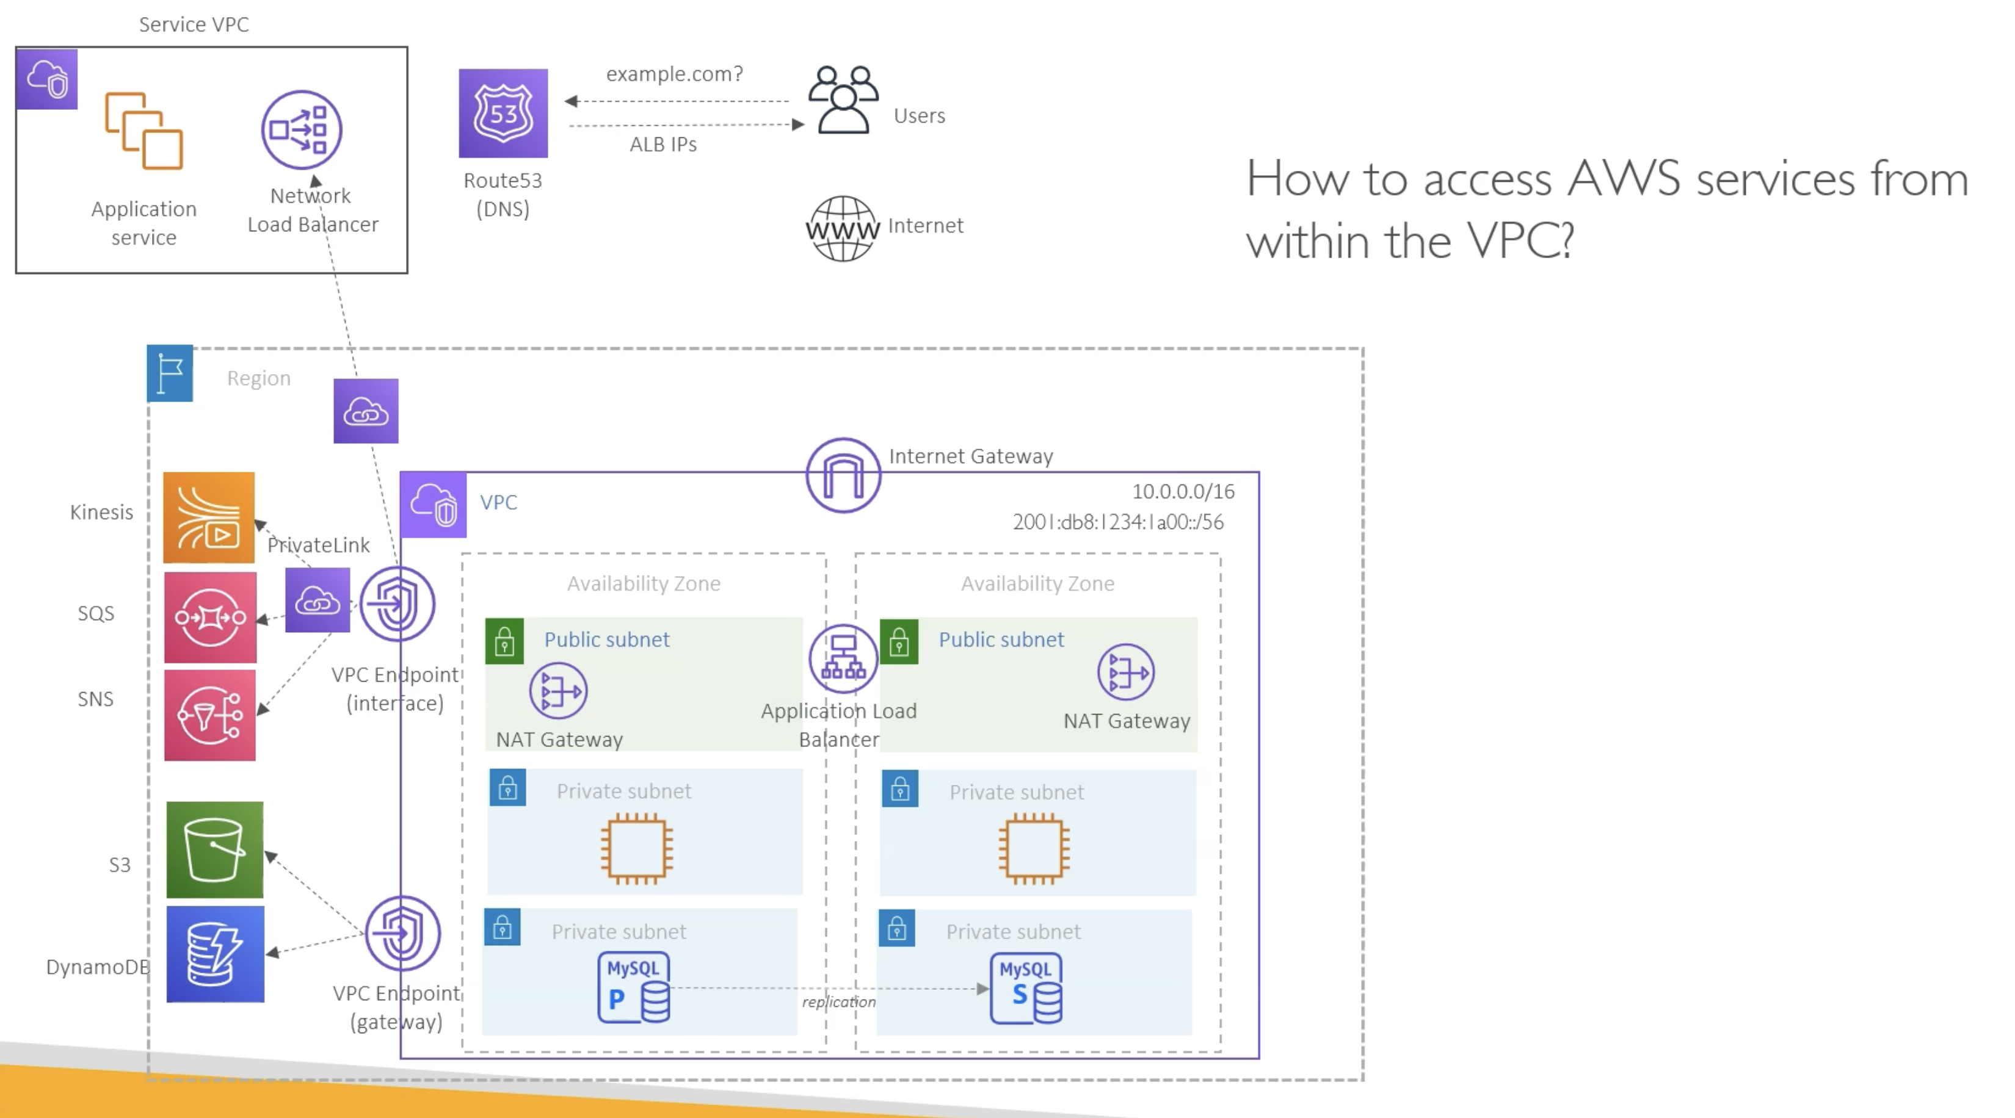

And further, let's assume that **your application wants to access some SaaS service.**

**SaaS is software as a service which is hosted in some other VPC** by someone else.

Now one option is again, they expose their services through the internet, and then your application access that service through the Nat gateway.

But AWS Private Link or say VPC endpoint also supports accessing these services privately.

Now for that, the SaaS service provider has to expose that service through the network load balancer.

And we are going to talk more about that in the following lecture.

But understand that in AWS, it is possible to consume other services outside of your VPC through VPC

endpoints and private link.

----------------------------------

How do you access AWS VPC privately from your on premises network?

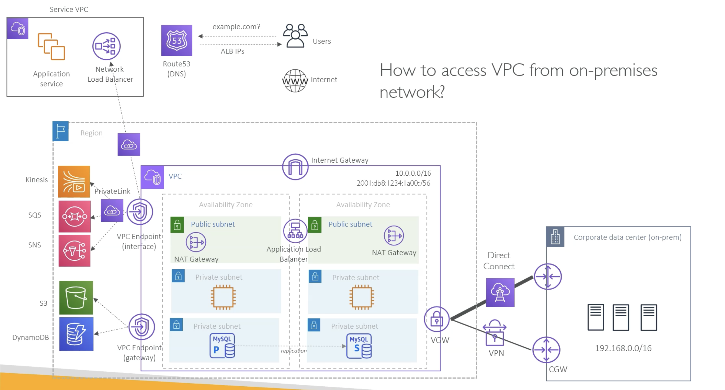

Also, there are a couple of options:-

1. Site to Site VPN
2. AWS Direct Connect

and the simplest option is to use site to site IPsec VPN.

So on AWS site you will have some gateway devices, and on customer site you will have your router.

And then you can setup AWS managed site to site VPN between these two networks.

And once you do that, the servers inside your corporate data centre can privately access, say, this application server or the databases, which is only having the private IP addresses inside your VPC.

So that's one option, which is a simple option.

But some customers need high bandwidth and consistent throughput because VPN traffic still goes over the internet.

It doesn't guarantee the network performance, and that's where other customers will go with something called AWS Direct Connect.

So Direct Connect is basically a physical connectivity between AWS and your on premises network.

How to access AWS VPC resources privately from a company’s/client VPN ?

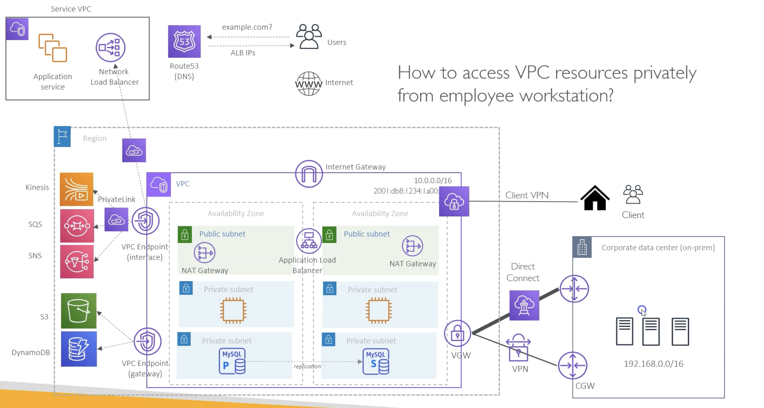

So you can privately access resources from the VPC if you are connected over AWS client VPN. So this is very similar to how you access your company network from your home. So for this in AWS you will create client VPN endpoint and then you authenticate yourself and can access now all these VPC resources privately from your workstation.

In real world there are 100s of VPCs. So, to connect them privately we have below options:-

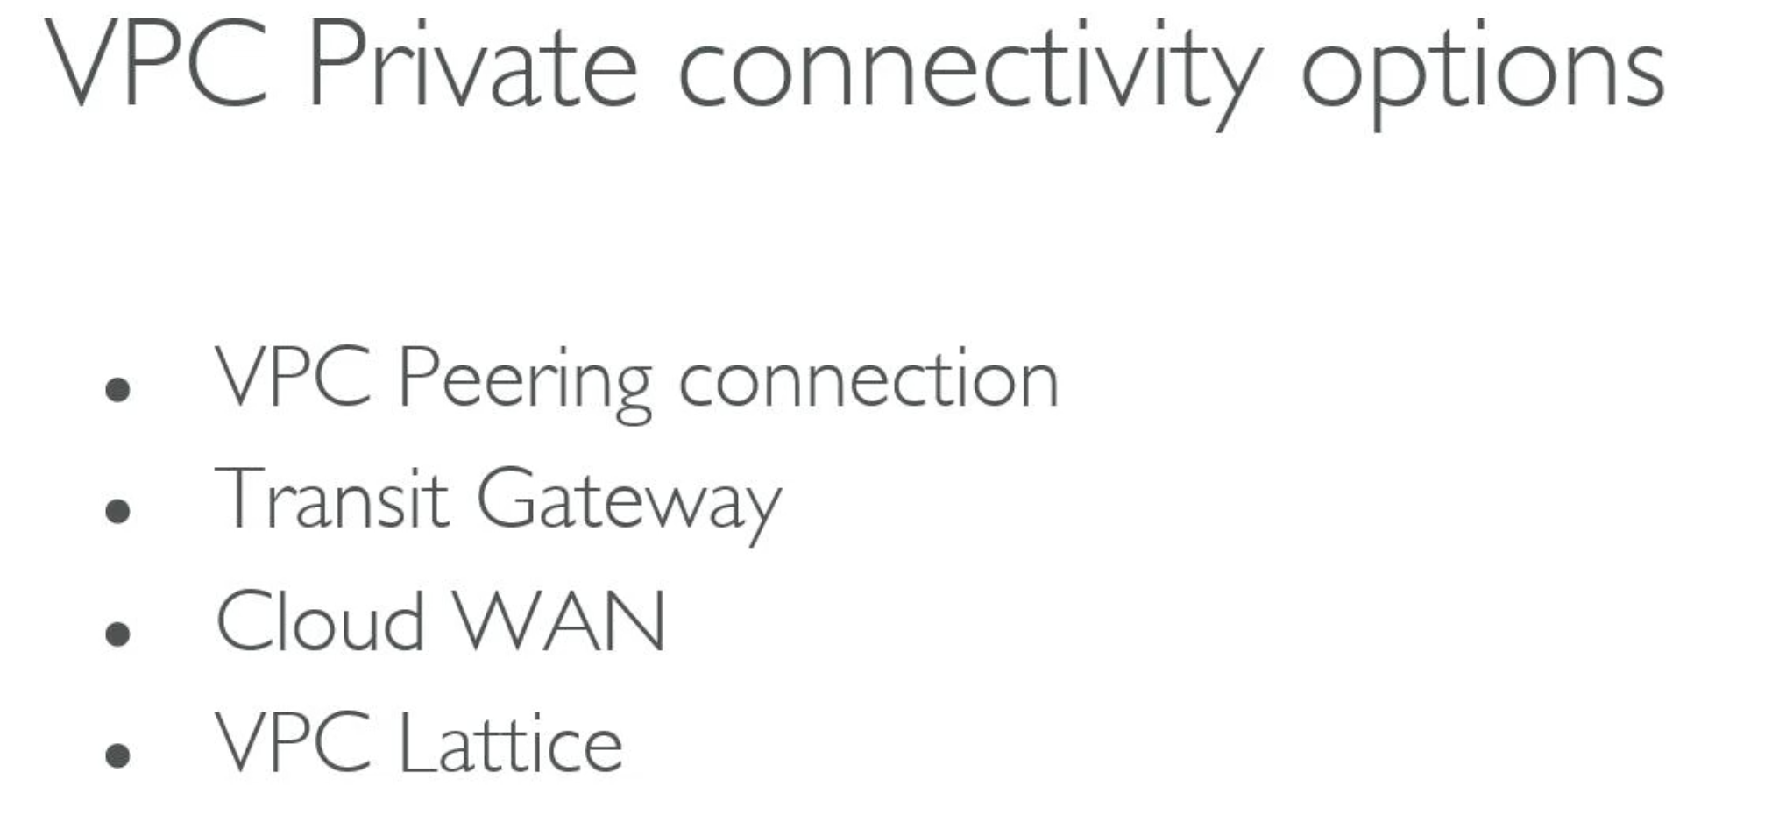

VPC Peering:-

VPCs can be in same AWS region or in different AWS regions.

1:1 mapping between VPCs

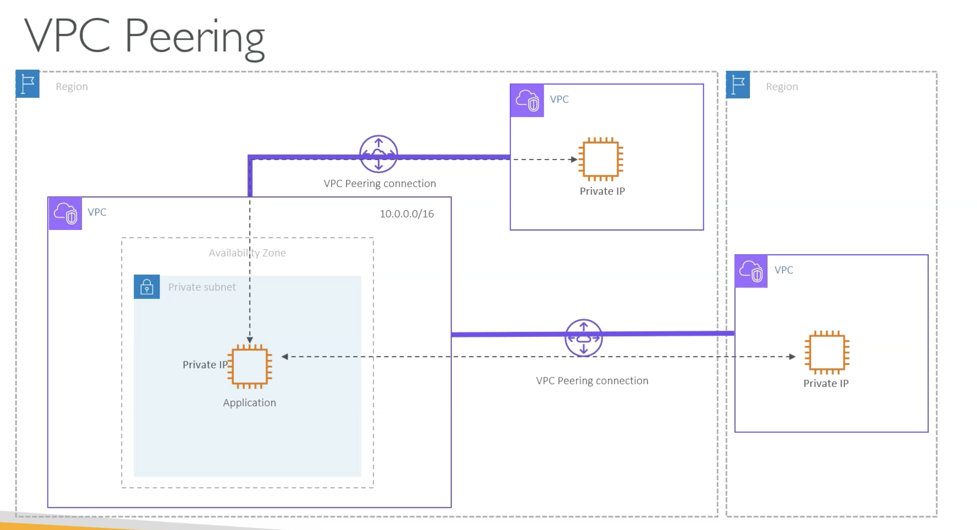

So, this works well if you have manageable number of VPCs. What if there are 100s of VPCs ? Then Transit Gateway Solution comes into picture.

Transit Gateway:-

Hub and Spoke Model

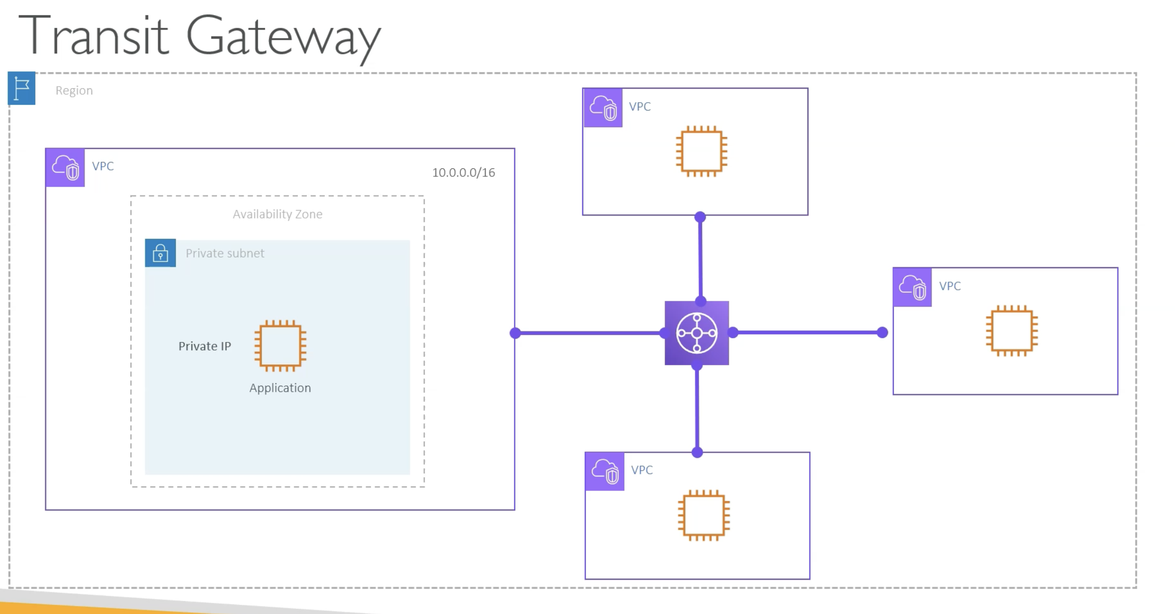

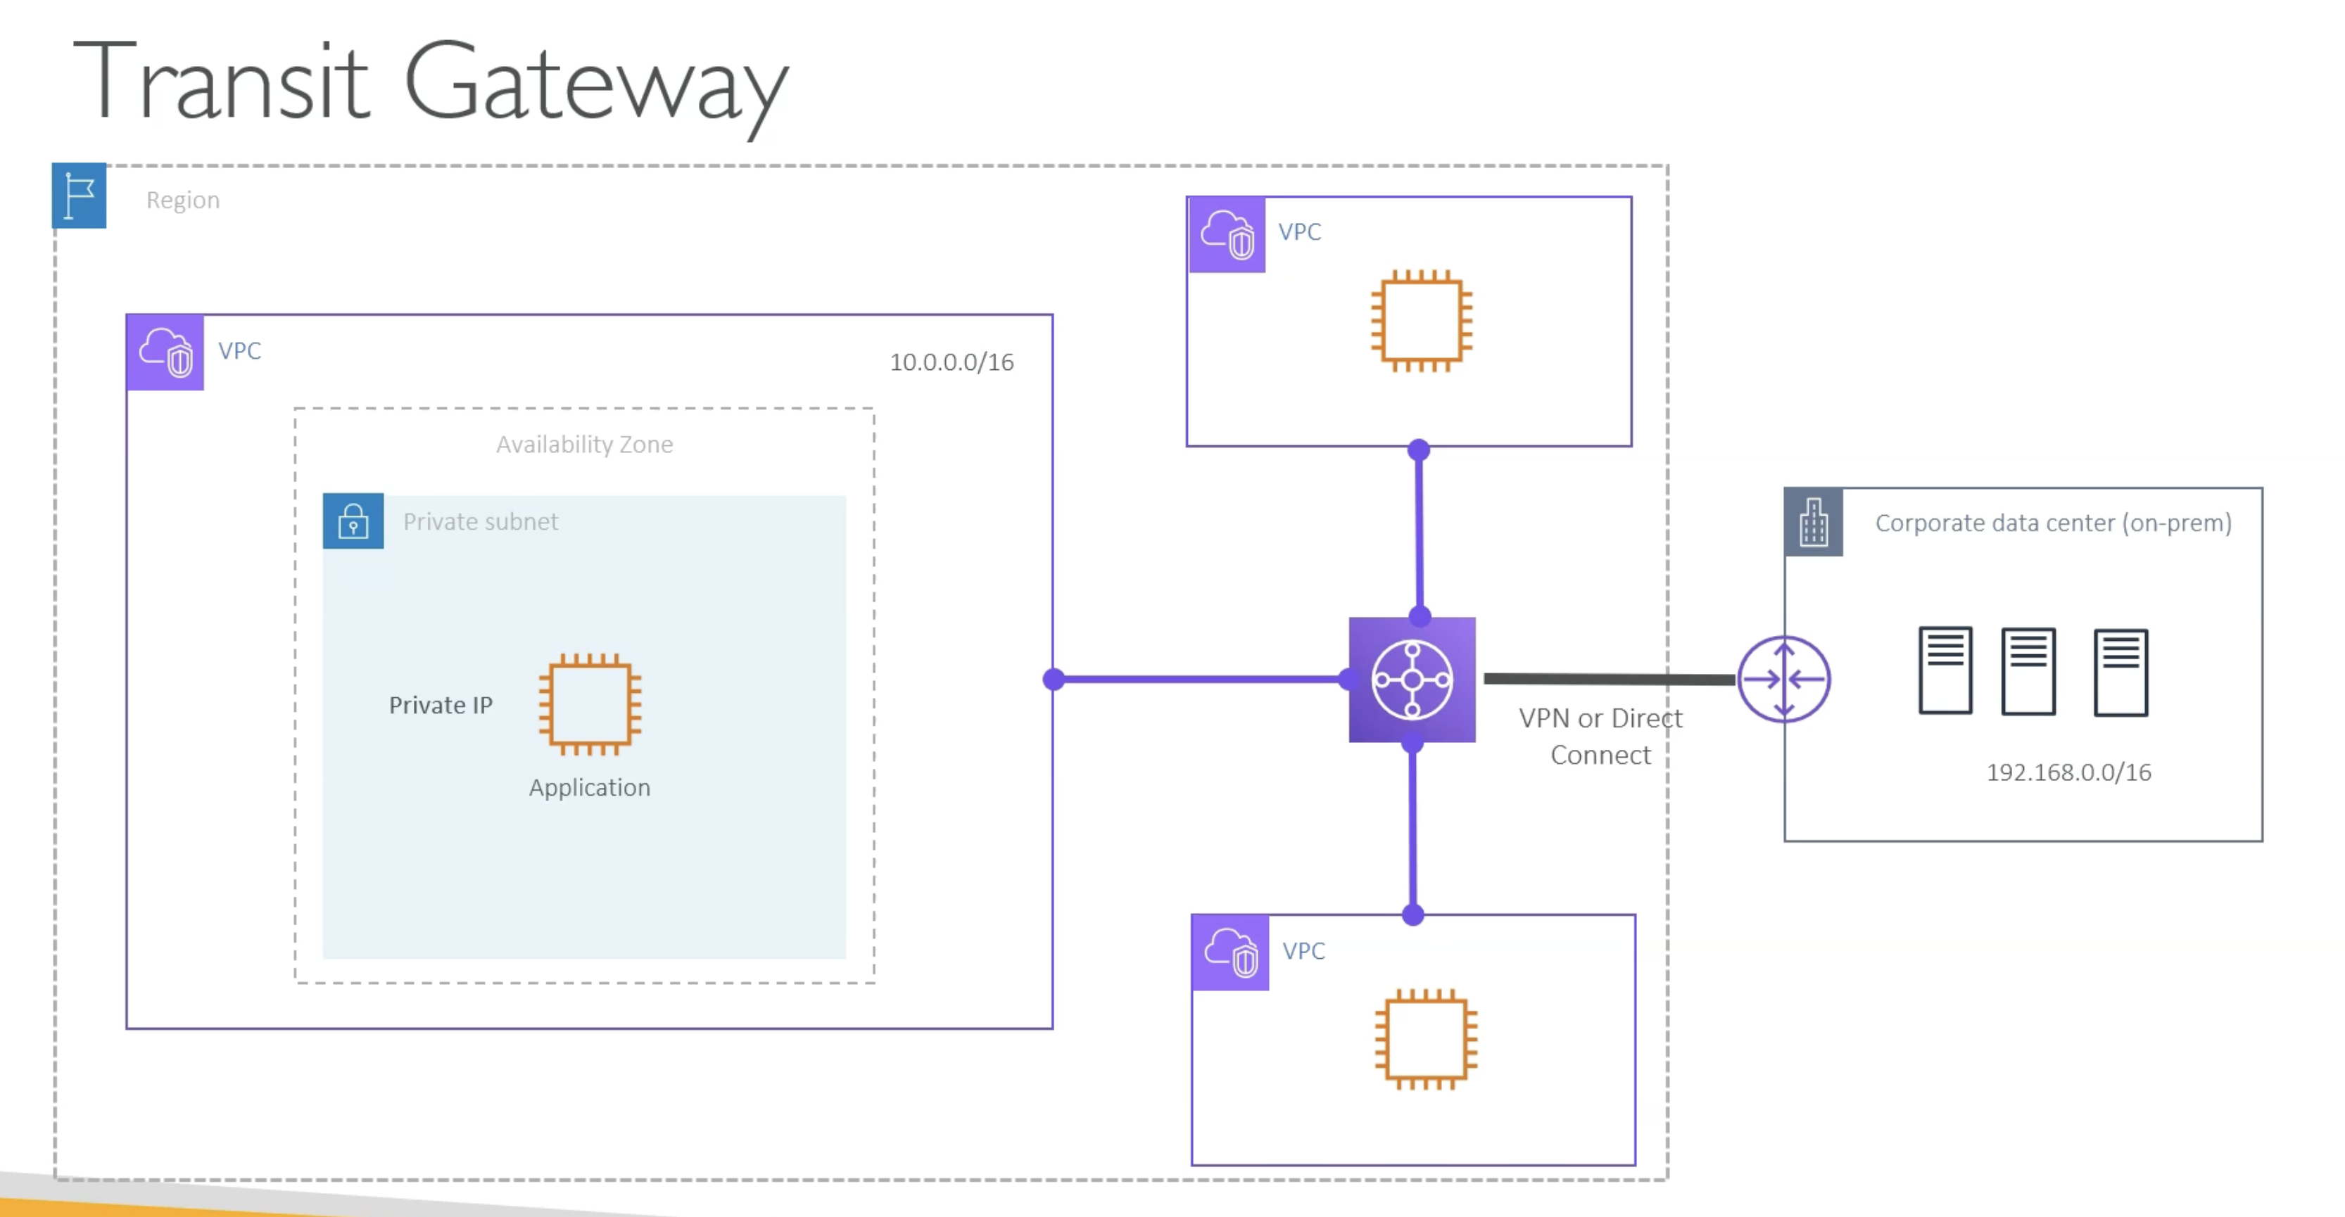

**Transit Gateways are regional component, i.e we can connect VPCs from same AWS region where Transit Gateway resides.**

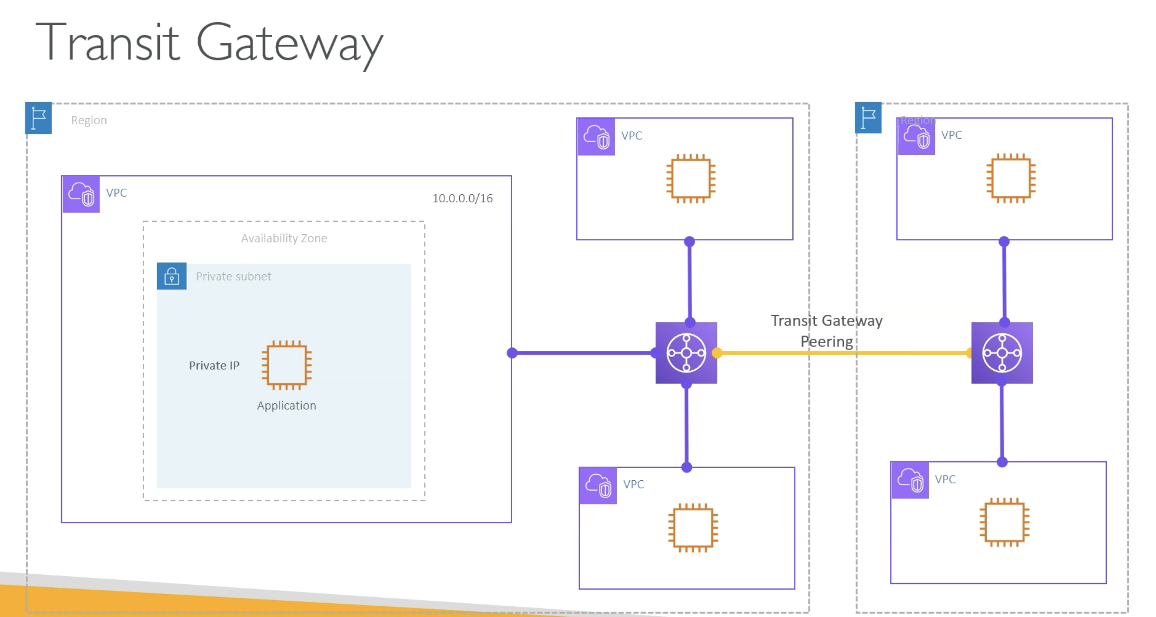

So what if you have VPCs in different AWS regions. So in that case, you will connect those VPCs to the transit gateway in that particular region.

And then you can have the transit gateway peering connection similar to what you did for the VPC peering.

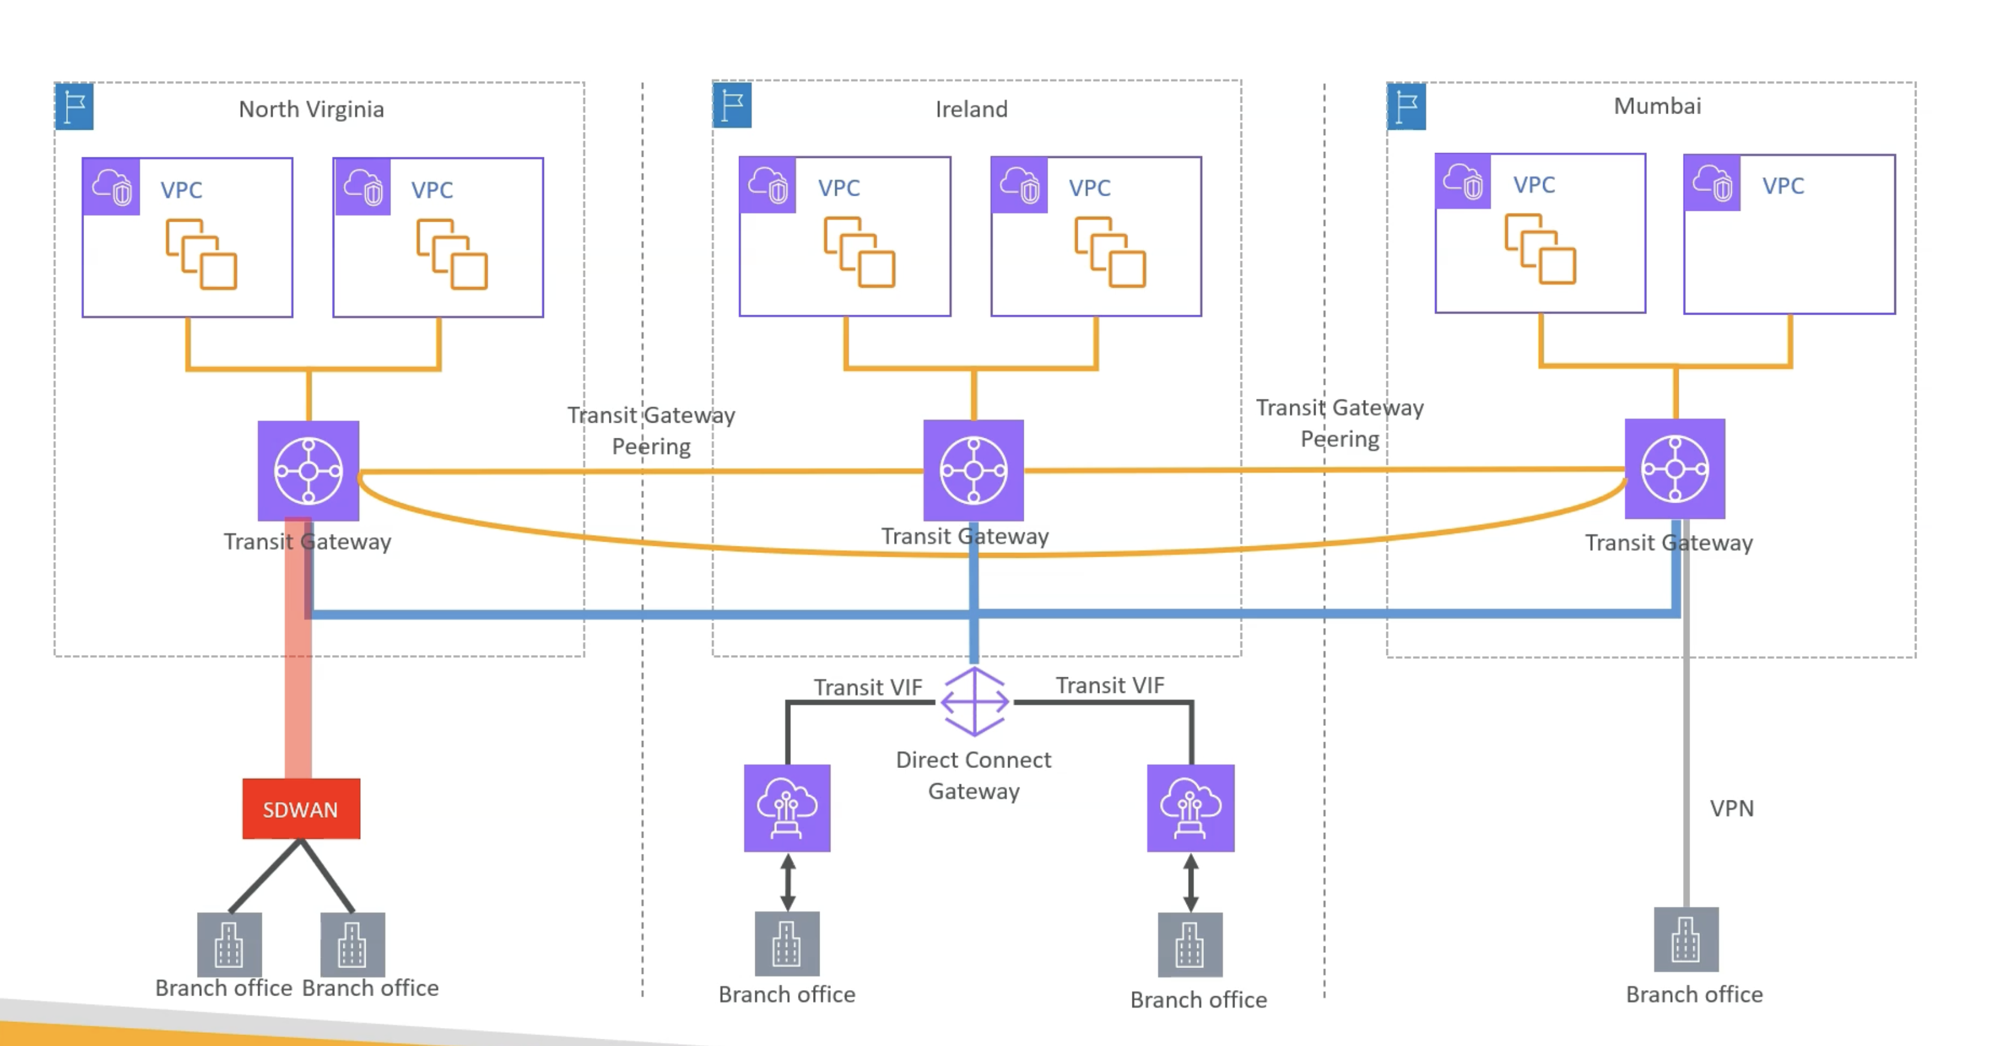

But again the same problem if you are using too many AWS regions right.

So what if you have ten regions and you want to connect VPCs across all those ten regions. So here I'm just showing three AWS region And then there are multiple VPCs. Now out of these VPCs let's imagine that some VPCs are for the development.

Some VPCs are to host the production application. So again you need some kind of segregation for the traffic between the development VPCs or the production

VPCs. So if you use Transit Gateway, then again, as you can see here, multiple transit gateway and multiple peering connection.

And as the number of regions increase, you will see the same complexity that we had faced for using the VPC peering connection.

And further, we can add complexity by also having your on premises network.

And again you need to connect that to the different transit gateways. So it can be done. And for that **you have to really play with transit gateway route tables** **where you can manage all this** connectivity.But it is very very complex. And further you can't manage that with say a policy document.

You have to really, you know, keep track of all those changes and all those route tables. So AWS also realized that this is not a scalable solution.

And that's where a couple of years back, AWS launched something like AWS cloud WAN.

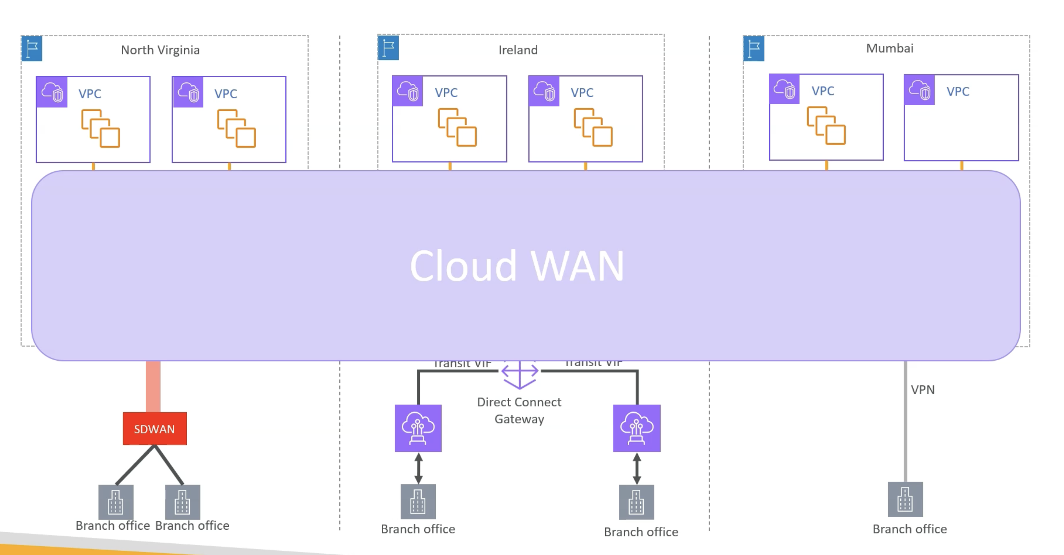

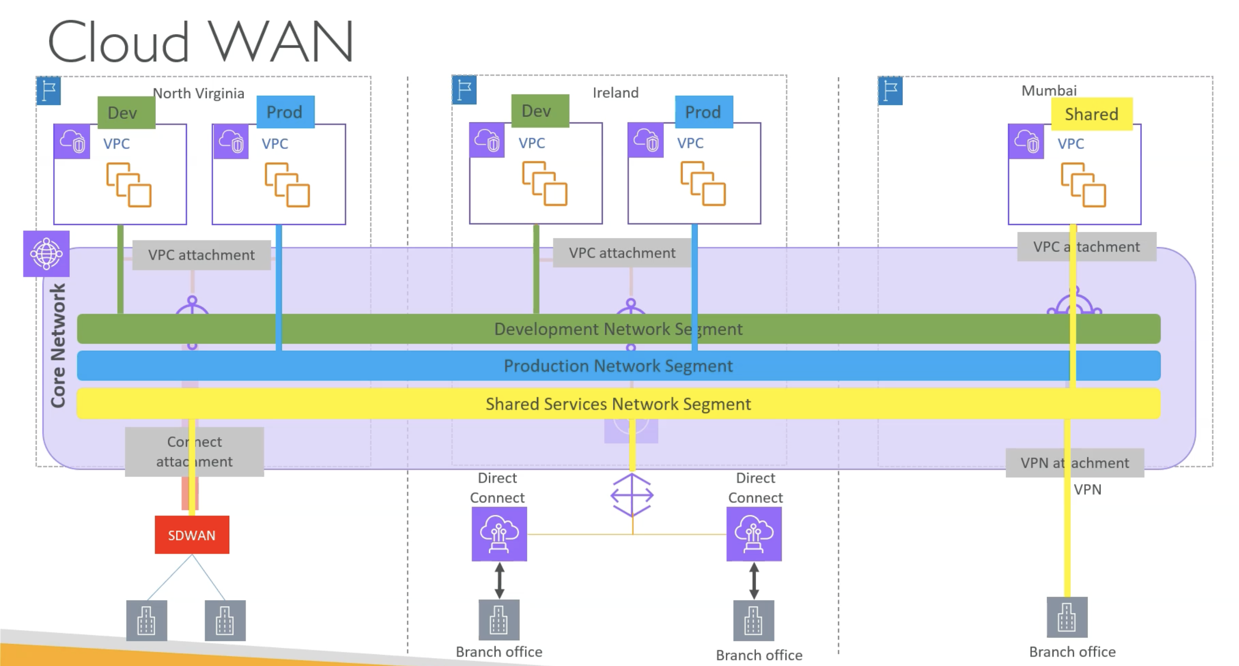

So cloud Wan solves this problem where it can span across all AWS region.

And it allows you to create the segments. For example, there will be a separate segment as a development segment, and you can name it as you want.

And then you can only associate VPCs which are for development to this segment.

Similarly, you can create a segment for production shared services, whatever.

But the point here is that now cloud Wan is managing all that network for you.

And you don't need to worry about all those route tables that Transit Gateway has.

So it is much better way to manage your global network.

There is another Networking service used for Application Networking i.e VPC Lattice

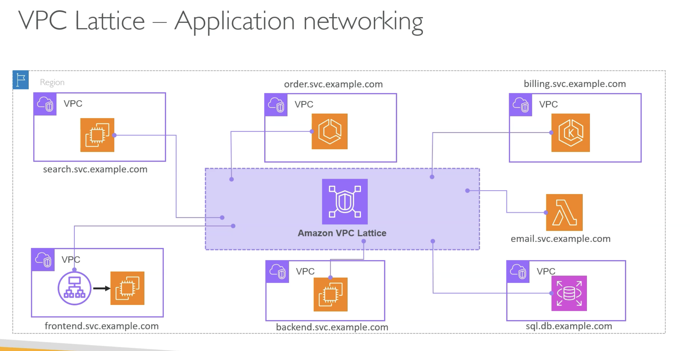

Now Lattice is more application level service.That means say you build a microservices based architecture, right? So you might have different services built by different teams, and they might decide to run these services on different computing platforms. For example, some teams might run it on EC2, some teams might run it on ECS or EKS. And every service will have their own domain name, for example.

And now, because they are hosted in different VPCs, you want to enable the communication between them and at the same time you need to resolve those domain names, and it is generally called a service discovery and for this kind of architecture you will use something called service mesh kind of networking component. So in the container world typically you will use some kind of proxy solution where it goes as a sidecar into your container. And then you manage this entire network. But recently AWS launched VPC lattice as a service for this where you create a VPC lattice network and then you associate all these VPCs as a lattice service to this network. Now all these services can communicate with each other.

And VPC lattice also handles the service discovery, the domain name management and everything. So it greatly simplifies your application to application networking.

Final Summary/Overview Diagram for quick understanding:-

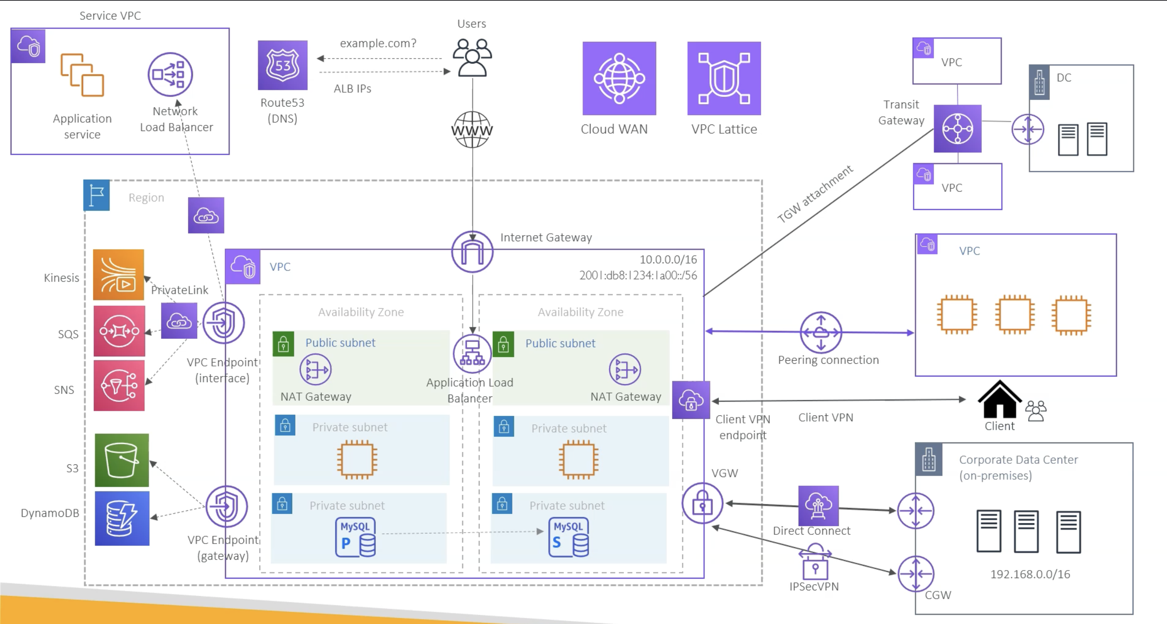

Next,

